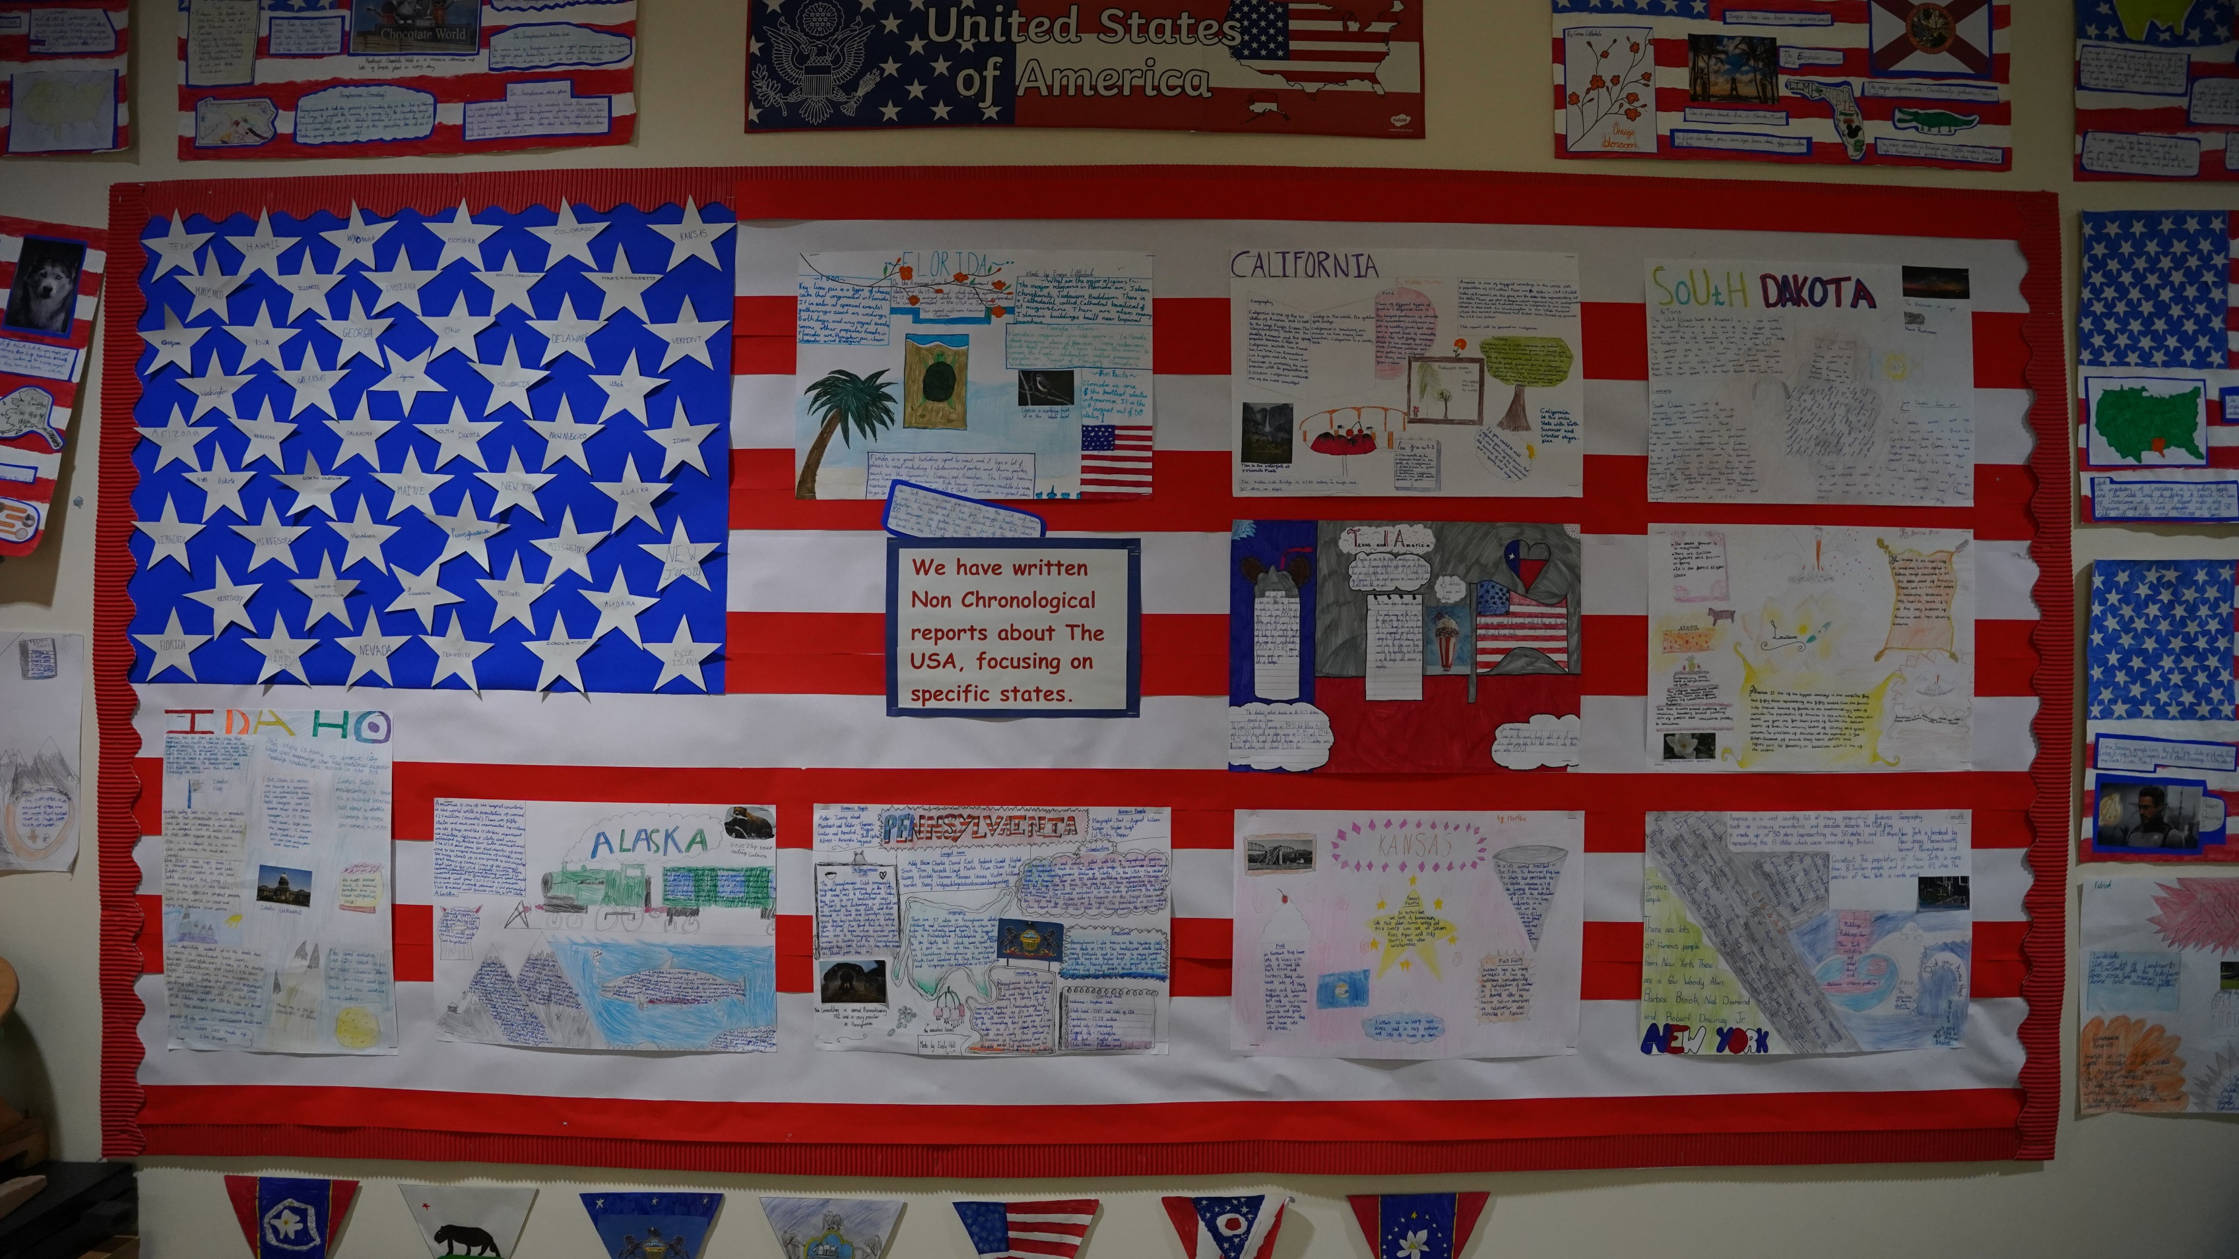
Grayswood CE
Primary School

History and Geography
Curriculum Overview
Overview of History and Geography Curriculum

Year | Autumn 1 | Autumn 2 | Spring 1 | Spring 2 | Summer 1 | Summer 2
1 | How am I making history? | What is it like here? | How have toys changed? | What is the weather like in the UK? | How have explorers changed the world? | What is it like to live in Shanghai?
2 | How was school different in the past? | Would you prefer to live in a hot or cold place? | How did we learn to fly? | Why is our world wonderful? | What is a monarch? | What is it like to live by the coast?
3 | British history 1: Would you prefer to live in the Stone Age, Iron Age or Bronze Age? | What do people live near volcanoes? | British history 2: What did the Romans settle in Britain? | Who lives in Antarctica? | What did the ancient Egyptians believe? | Are all settlements the same?
4 | British history 3: How hard was it to invade and settle in Britain? | Where does our food come from? | British history 4: Were the Vikings raiders, traders or settlers? | Why are rainforests important to us? | How have children’s lives changed? | What are rivers and how are they used?
5 | British history 5: What was life like in Tudor England? | What is life like in the Alps? | How did the Maya civilization compare to the Anglo-Saxons? | Why do oceans matter? | What did the Greeks ever to for us? | Would you like to live in the desert?
6 | British history 6: What was the impact of WW11 on the people of Britain? | Why does population change? | Unheard histories: Who should go on the banknote? | Where does our energy come from? | What does the census tell us about our local area? | Can I carry out an independent fieldwork enquiry?

