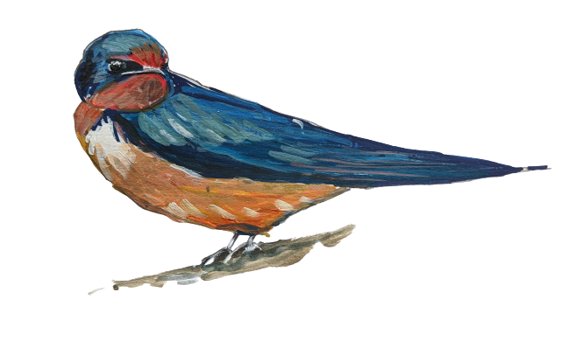
YEAR 4 SWALLOWS
Class Teacher/s: Mrs Coult and Mrs Fairhurst
Learning Support Assistant/s: Mrs McQuillan (Monday – Wednesday mornings; Mrs Rose Callaghan (Thursday–Friday mornings)
Important diary dates and reminders
Year 4 class assembly – Thursday 12th March. The children have been given their lines to learn and have an idea of costumes they could put together. Costumes are not essential and just for fun! They also have a song to learn and hopefully will be singing it so much you’ll be ready to join in on the day.

Rescue the Rainforest Fair – Friday 13th March 3:10-4:00 A few parent volunteers would be much appreciated! Whilst the children are planning and running all the activities, it would be wonderful to have a bit of parental support. If you can help with set up (from 2:30 Friday 13th) or with supervising a stall, please do email Mrs Fairhurst. There will be a special guest (details in the homework section) which means we anticipate the children will be finished at 4:30 and we hope to see as many of them there as possible.

Kew Gardens trip – 19th March
KIRFs: Our KIRFs this term will be to know the x and ÷ facts for the 7x tables. We have attached the information sheet at the end of the newsletter. Please support your child with the learning of these key facts. We also attach a times table sheet that you might find supportive.
Class update
Welcome back to the second half of the Spring Term! We hope you all had a restful break and are feeling refreshed for what is set to be a busy and very short half term. With so much to fit in over the coming weeks, we’ll certainly be making the most of every day. Let’s hope the weather is on our side as we head towards brighter days and lighter evenings! We’re looking forward to a positive and productive few weeks ahead.
In English, we looked started to look at newspaper reports, exploring their features and identifying what may make a good headline. We had fun looking at the various puns you can find in newspapers, especially the tabloids!
In Maths, we started a new unit of work: Fractions. We did assess their knowledge of multiplication of division and although many did well and showed good progress, they must stop, read the question, and apply their understanding. Jottings can be a vital support too in helping them answer more complex questions.
In their fraction work, it was very important that the children were secure with the fact that when the numerator is equal to the denominator then the fraction is equivalent to 1. We developed their understanding of mixed numbers e.g 3 ¾ and we partitioned mixed numbers in different ways – a skill that will be vital for later steps in their learning. For example (for example, 3 14 = 2 + 1 14 ) or 2 34 = 2 14 + 24 ).
Spellings
Here are the new spellings for next Wednesday. Please also complete the assignments set on Spelling Shed and enjoy playing the games.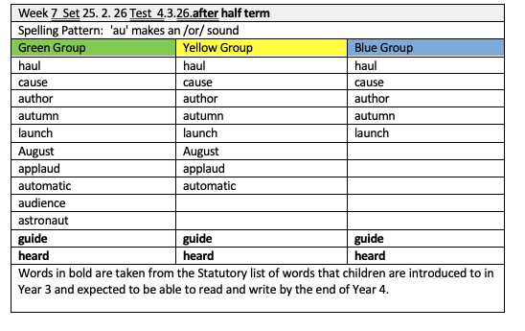Home learning
The children should record their work in their blue homework books this week. We are happy for any homework completed to be handed in on Thursday of the following week. An explanation of the tasks can be found below:
Maths – The Maths homework is to complete the fractions activities on Mathletics.
English – The children should make a poster for their Rescue the Rainforest fair which is on Friday 13th March at 3:10-4:00. They need to include the date, the time and the activities on offer.
We have exciting news! The class wrote amazing letters regarding the rainforest and sustainable palm oil to our local MP, Greg Stafford. He was so impressed by their letters that he is going to come along to the fair, meet the children and give them individual letters in response. We do hope you can join us.
Have a lovely weekend,
Mrs Coult and Mrs Fairhurst


