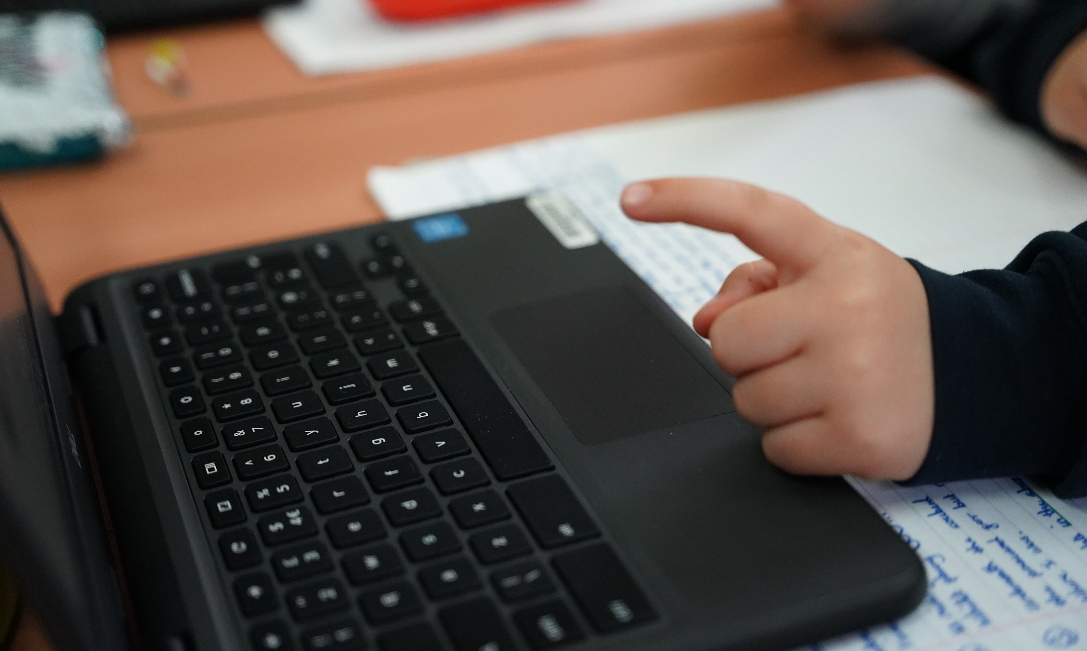
Grayswood CE
Primary School

Computing
Curriculum Overview
Year | Autumn 1 | Autumn 2 | Spring 1 | Spring 2 | Summer 1 | Summer 2
EYFS | Online Safety | Computing systems  and networks | Programming 1 | Computing systems  and networks | Data Handling | Programming 2
EYFS |  | Using a computer | All about instructions | Exploring hardware | Introduction to Data | Programming Bee-bots
1 | Online Safety | Computing systems  and networks | Programming 1 | Creating Media | Programming 2 | Online Safety (Recap)
1 |  | Improving mouse skills | Algorithms unplugged | Digital Imagery | Programming Bee-bots | Online Safety Y1
2 | Online Safety | Computing systems  and networks | Programming 1 | Programming 2 | Data Handling | Computing Systems and Networks 2
2 |  | What is a computer? | Algorithms and Debugging | Programming MakeCode | International Space Station | Word Processing
3 | Online Safety | Computing Systems and Networks 1 | Computing Systems and Networks 2 | Computing Systems and Networks 3 | Creating Media | Programming
3 |  | Networks and the Internet | Journey inside a computer | Emailing | Video Trailers | Scratch Jr
4 | Online Safety | Computing systems  and networks | Programming 1 | Programming 1 | Data Handling | Programming 2
4 |  | Collaborative learning | Further coding with Scratch | Further coding with Scratch | Investigating weather | Computational Thinking
5 | Online Safety | Computing systems  and networks | Programming | Data Handling | Skills Showcase | Creating Media
5 |  | Search engines | Programming music | Mars Rover 1 | Mars Rover 2 | Stop Motion Animation
6 | Online Safety | Computing systems  and networks | Data Handling | Computing systems  and networks | Programming | Skills Showcase
6 |  | Bletchley Park and History of Computers* | Big Data 1 | AI | Introduction to Python | Inventing a Product
Overview of Computing Curriculum
Online Safety is taught at the start of each academic year by all classes and regularly brought into the other units where applicable as they are studied.
*Units merged September ’24. History of Computers replaced with AI, a newly created unit for Year 6.

